______________________________

**Software Requirement Specification**

**For**

**“Hospital Management System”**



**Prepared by**

Vasoya Jay

**Software engineering**

February 20, 2024

Certificate

Certified that this is the bona-fide record of the project work titled

**SRS REPORT**

**On**

**Hospital Management system**

Prepared By:

Vasoya Jay

Of the first semester of CE/IT in the year 2024 in the partial fulfilment of the requirement for the award of degree of bachelor in engineering.

Zalak Bhavasar Ms. Khooshbo shah

Head of department Project guide

**ACKNOWLEDGEMENT**

This satisfaction and euphoria that accompany the successful completion of any task would be incomplete without mentoring the names of the people who made it possible, whose constant guidance and encouragement crowns all the efforts with our success. We extend our gratitude to Mrs. Khusboo Shah Head of Department of Computer Science Engineering/ Technology, LJ Institute of Engineering and Technology, Ahmedabad, Gujarat for providing us with an excellent infrastructure and awesome environment that laid potentially strong foundation for our professional life. We would like to express our profound thanks to our professor cum project guide Mrs. Khosboo shah, who guided us through this project tenure, provided us each and every information, references and technical helps without which it was impossible to complete this project. Finally, we would also like to thank all guest faculties and non teaching staff for supporting us during our whole project work.

**Abstract**

This hospital has required a system that maintains its hospital Management System as well as keeps the record of the Hospital in database. This software manages all information about patient name, patient address, doctor information, staff information etc. it also stores daily information of patient Which is done by doctor. Also store information about billing, finally it calculate total bill of patient

**Table of contents (SRS)** **1.Introduction……………………………………………………………………………….….5** 1.1 Purpose…………………………………………………………………………………5

1.2 Intended Audience…………………………………………………………….….6

1.3 Scope………………………………………………………………………………….…5

1.4 References ……………………………………………………………………….…..5

1.5 Overview …………………………………………………………………..…….…..6 **2.OverallDescription………………………………………………………………….….6**  2.1 Product Perspective………………………………………………………...……6

2.2 Product Feature……………………………………………………………...……6

2.3 Operating Environment………………………………………………………..6

2.4 Design and Implementation Constraints………………………………6

2.5 User Documentation……………………………………………………………7

2.6 Assumptions and Dependencies………………………………..………..7 **3.System Features and Requirements…………………………………………....8** 3.1 System Feature .………………………………………………………………....8

3.2 Technical issues………………….…………………………………………….…9 **4.External Interface Requirements……………………………………………….10** 4.1 User Interfaces……………………………………………………………………10

4.2 Hardware Interfaces…………………………………………………………..10

4.3 Software Interfaces……………………………………………………………10

4.4 Communication Interfaces…………………………………………………10

**5.Other Non-functional Requirements…………………………………………11**  5.1 Performance Requirement....................….................11 5.2 Safety Requirements…………………………………………..…...…………11

5.3 Security Requirements…………………………………………………………11

5.4 Software Quality Attributes……………….……………………………….11 **6.Diagrams……………………………………………………………………………………..12** 6.1 Flow chart………………………………………………………………..………….13

6.2 State diagram………………………………………………………………………14

6.3 Sequence diagram…………………………………………………………..…..15

6.4 Use case diagram …………………………………………………………………16

6.5 Activity diagram……………………………………………………………………17

.6.6 Class diagram……………………………………………………………………….18 **7.Other requirement……………………………………………………………………….19** **8.Conclusion…………………………………………………………………………..……….19**

**1.INTRODUCTION:**

**1.1 Purpose:** This document lists the requirement specification for an Hospital Management System (HMS). The document is changeable as per changing in requirement and changes are covered in the document. The given version of document is the initial one.

**1.2 Intended Audience:** The untended audience for this document consists of requirements engineers, developer, tester, designers and project manager.

**1.3 Scope:** Subject facet: User Interface, Searching nearest hospital, Searching the availability of bed, Searching staff and doctor information, entry of patient (Like: patient condition and name etc.).

Usage facet: Searching, sorting of bed, Display the information of hospital, manage patient’s details, keeping bed availability up to date.

IT facet: Database, Web site and application-based system, performing the system well, short response time.

Development facet: Internal policy of the hospital should be taken under the system.

**1.4 Reference Documents:**

1.Software Engineering by K.K.Aggrawal, Singh, Yoges1.4

2.Lan Somerville, Software Engineering. Third Edition.

3.Programming In Visual Basic 6.0 by Julia Case Bradley.

4.Introduction to Visual Basic 6.0 by Gary Haggard, Wade Hutschan.

**1.5 Overview:**

The remaining part of document will give the better understanding of the HMS system which defines product perspectives and functions , use-case diagrams, classes of involved users, contains the design and implem entation of the system. Also gives user documentation, assumptions and dependencies.

focus on the userrequirements such as a functional requirements and non-functional requirements, specify the goal of the system, some diagrams conduct in this document for model requirement like class diagram, sequence diagram, state diagram etc.

Document also include user, hardware, software and communication interface requirements. Attributes of the software system are specif ied in the document. Prioritization and traceability of requirements are also included in the document.

**2.Overall Description:**

**2.1 Product Perspective**:

This Hospital Management System is a self -contained system that manages activities of the hospital as patient info. Various stakeholders are involved in the system like staff, doctors…etc. The system contained all kind of information of doctors and staff of hospital.

**2.2 Product feature:**

The functions of the system described as follow:

**Registration:** When a patient is admitted, the front-desk staff checks the available bed and to see if patient is already registered with the hospital.

Now if he/she is, his/ her personal health number is entered into the system. Otherwise a new Personal health number(patient id) is given to this patient.

The patient’s information entered into system . And enroll the patient as per their condition in ICU and general word.

**Patient discharge:** If a patient check-out, the staff shall delete his personal health number from the system and make changes to the available bed listand also the system display the patient bill.

After the check -out of patient the system store all the information of patient to admitted history.

**2.3 Operating Environment:**

The system shall be the web -based or application - based. And independent to the operating systems.

System should Operate in all conditions.

**2.4 Design and Implementation Constraints:**

**1. Database:**

The system shall use the MySQL Database, which is open source and free.

**2. Operating System**:

The system should be independent to the operating system. Which means that the system work on every operating system(like, windows, Linux, mac, ….etc.)

**3. Web-Based:**

The system shall be a web-based application.

**2.5 User Documentation :**

The system stores the user information to the admitted history for future use and also stored bill regarding information.

And not only for patient but also for doctor system stores all information of doctors.

**2.6 Assumptions and Dependencies:**

It is assumed that the hospital have the important resources for the system like computer.

It is assumed that hospital have trained staff for working and take care of the system.

It is assumed that hospital staff respect the user privacy.

**3.System Features and Requirements (Functional Requirements):**

**3.1 System feature 1 (Description):**

**Registration:**

Add patients:

The HMS shall allow the front-desk staff to add new patients to the system.

Bed allotment:

The HMS shall allow the front-desk staff to check the availability of bed and as per the patient condition allot bed to patient.

Assign ID:

The HMS shall allow the front-desk staff to give an id to each patient. That used by the patient in hospital for all services.

The HMS shall allow the front -desk staff to manage patient detail throughout the patient stay in hospital.

Update details:

At the time of patient discharged staff shall update bed details and HMS stored the patient details.

**Report Generation**:

Patient information:

The system shall generate report on patient information: patient’s PHN, patient’s name, ward name , bed number and the doctor’s name and also save the billing information.

Bed availability:

The staff generates bed availability reports on bed availability about following information: ward name, bed number, occupied/unoccupied.

**Database:**

Patient Mandatory Information:

Each patient have the following mandatory information: first name, last name, phone number, address, pin code, city, country, legal ID.

**3.2 Technical issues:**

Database:

Some time technical issue occurs in database and system should fail for perform.

And also because of issue in database the system will become slow for response.

System should not able for collect Data and manage record of patient and doctors.

**4.External Interface Requirements:**

**4.1 User Interface:**

The software provides short response time to user also the good graphical interface for user. Any administr ator can operate on the system, And sys tem provides task to user like update, create, view details and also generate documents.

Allow user to view quick reports like bill, details of patients etc. In very short time.

System also user to search facility in the system based on different criteria.

**4.2 Hardware Interface:**

Operating System : Any(Like Windows, Ubuntu, Linux, mac..etc. )

Hard disk : 48 GB

RAM : 256 MB

Processor : Pentium(R)Dual-core CPU

**4.3 Software Interface:**

java language.

Notepad ++ .

MS SQL server

**4.4 Communication Interface:**

windows, Linux, Ubuntu etc.

**5.Other Non- Functional Requirements:**

**5.1 Performance Requirements:**

System should be able to handle 1000 entry and also same amount of billing per second.

**5.2 Safety Requirements:** System should include restore and recover functions in order to prevent data loss.

System should assure data integrity.

**5.3 Security Requirement:**

System should have an Authentication and Authorization System(AAS) for logins.

System should grant administrative privileges only to the one who logins with predefined administrative username and password.

System should allow administrator to change his/her system-generated password as he/she wishes.

System should allow administrator to login with customized password.

System should block access to one who fails to login five time in rows.

System should guarantee the security of communication channel.

Customized password should be 4 character long and also Include 1 symbol.

**5.4 Software Quality attributes:**

Usability:

Non-technical background of a user should not be an obstacle to understandand use the system.

Robustness:

System should be able to display the most recent inquiry by the user in

case of refreshment of page after sudden connection lost.

**6. Diagrams**

**6.1 Flow chart:-**

In this flow chart the entry of the patient was represent.

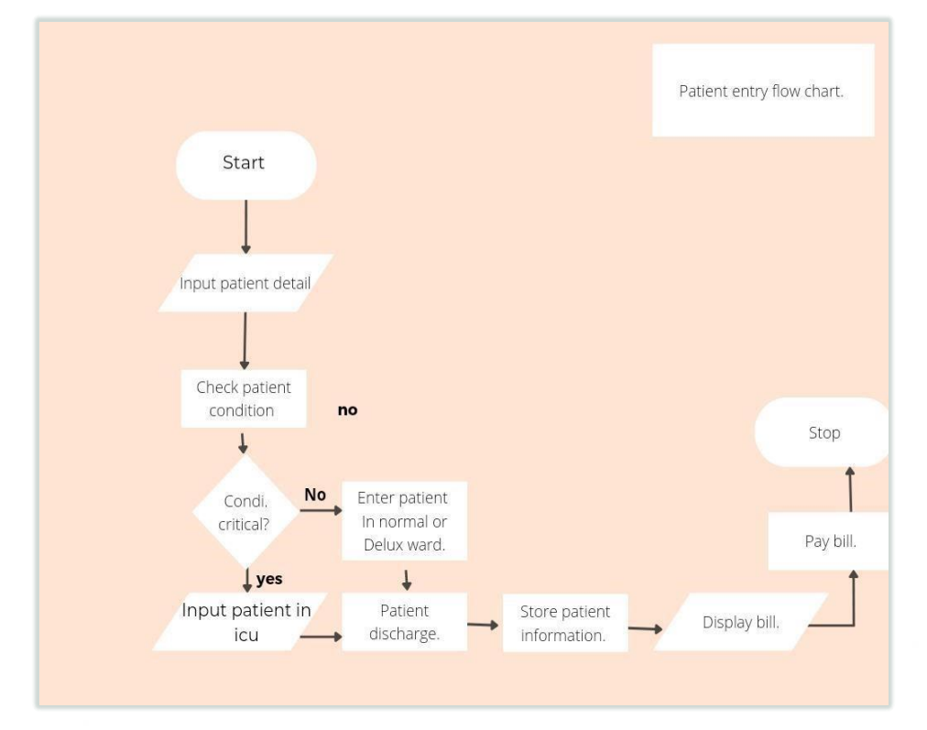

**6.2 State diagram:-**

State diagram specify the sequence of State of an object.

State diagram for bed allotment .

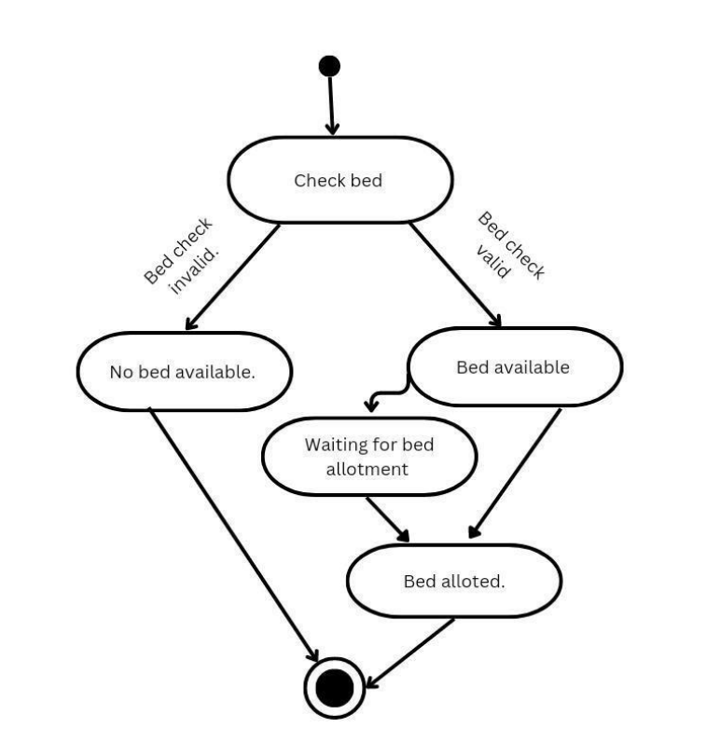

**6.3 Sequence diagram:-**

It represent the interaction of an object in sequence.

Sequence diagram for inquiry of staff

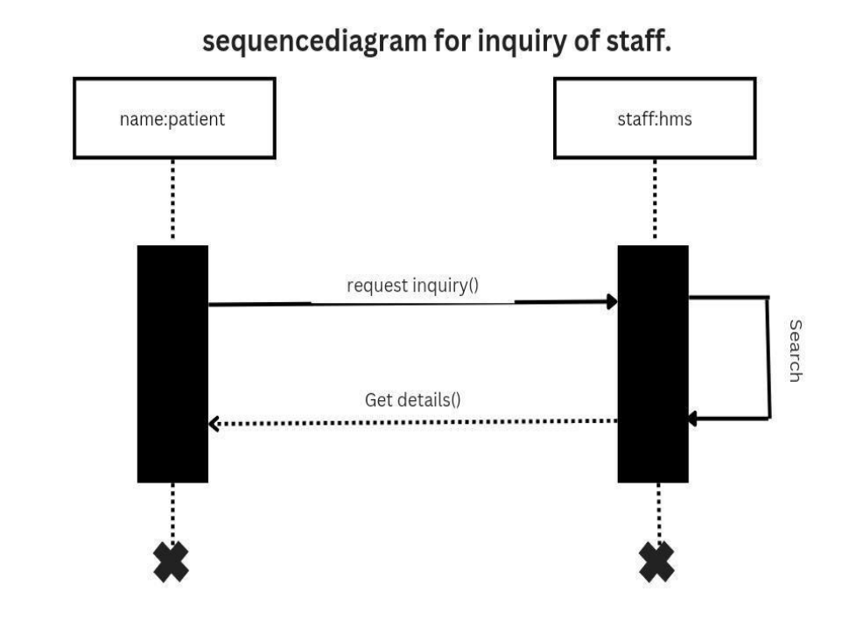

**6.4 Use case diagram :-**

Use case diagram for determine relations between different users.

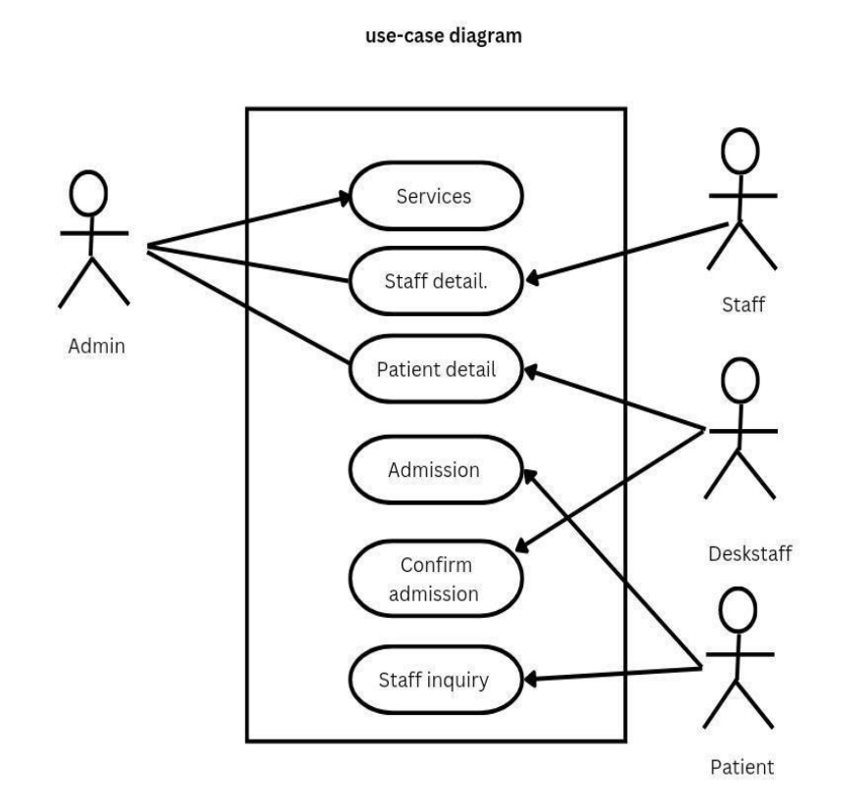

**6.5 Activity diagram :-**

the activity diagram describe the flow of activity through the series of actions.

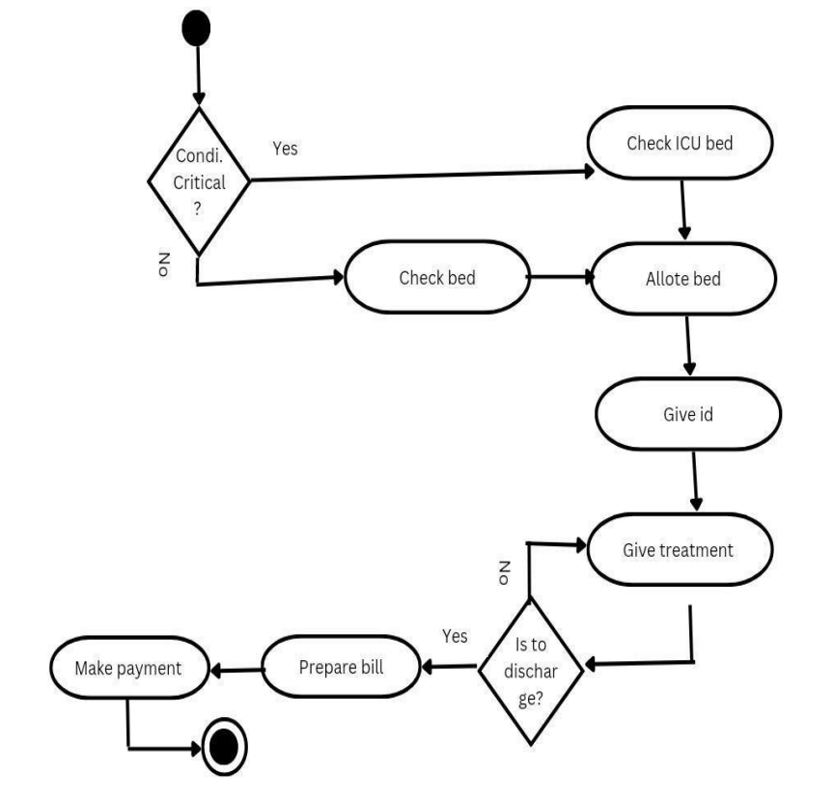

**6.6 Class diagram:-**

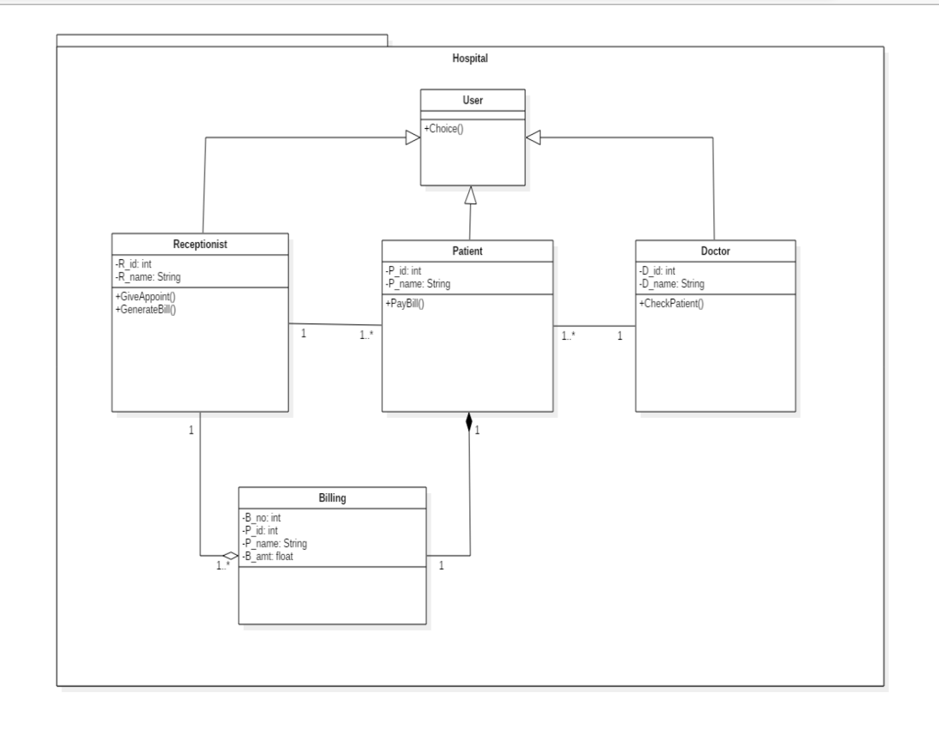

**6.7 DFD (Data Flow Diagram):-**

**Level 0 :**

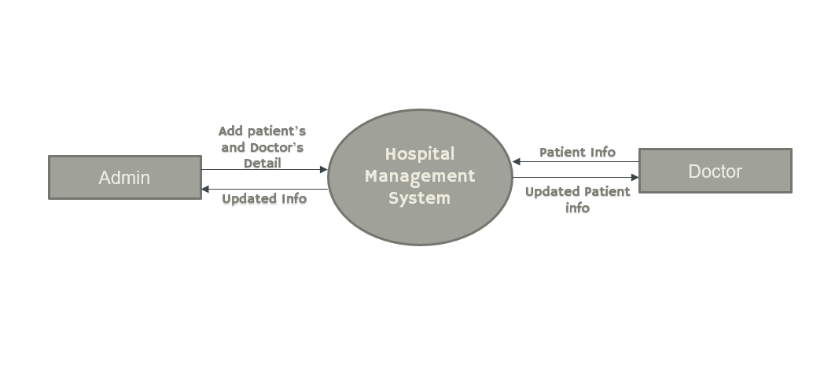

**Level 1 :**

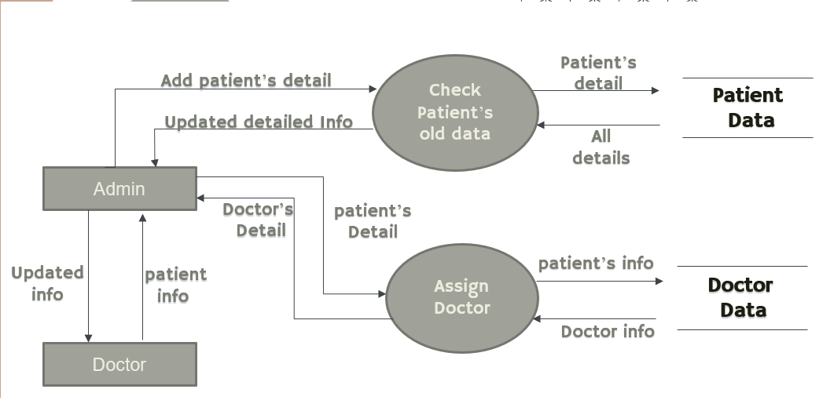

**Level 2 :**

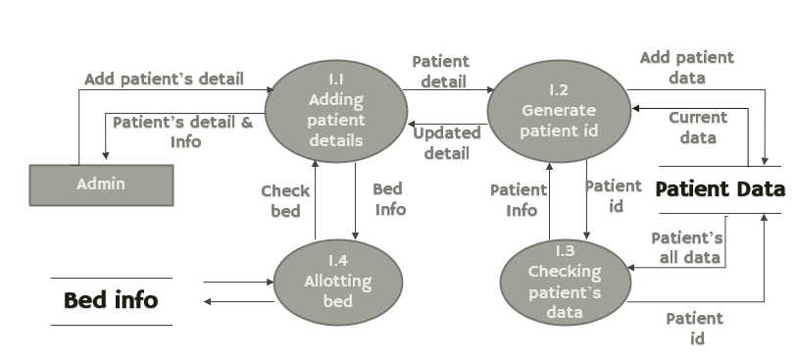

**7. Other Requirements:-**

A degraded mode of operation should be possible in which each system can operate independently of central scheduling. The software shall have failure and error recognition codes acting as a safety net, thus keeping the software from performing any major catastrophic functions.

**8. Conclusion :-**

Implementation of hospital management system project helps to store all the kinds of records, provide coordination and user communication, implement policies, improve day-to-day operations, arrange the supply chain, manage financial and human resources, and market hospital services.